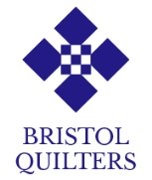

ZOOM Workshop with Nicholas Ball

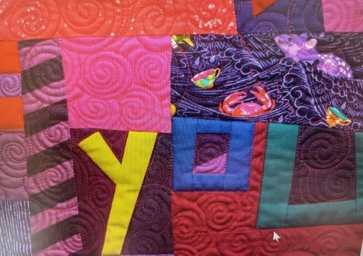

Improv ABC - a workshop focused on creating text using improv letters. We will be looking at how to create the whole alphabet, along with some punctuation

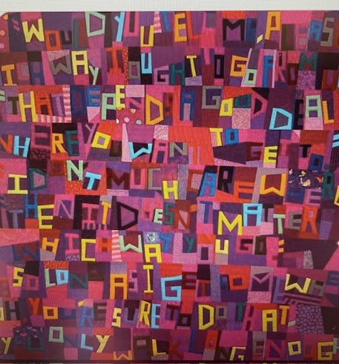

You can use this improv alphabet to create any message you like. The letters can be speedily made from strips and are easy to scale up or down. You can add variation to the letters by using a mixture of strip widths, or using a scrappy background

Class requirements list will be sent nearer the time

Date Sunday 15th September 2024

Venue Zoom

Time 10-1

Cost £30 ( Bristol Quilters non member)

I wish to attend the above Workshop

Name

Address

Contact Phone number
email address

I have paid £ into the Bristol Quilters bank account via online banking to

Lloyds
Account name Bristol Quilters (Business Account)
Sort Code 30-99-50
Account number 30662162

Please reference using WKSP followed by your initial and surname.
Please email this form to Andrea Marks andreadizzy@gmail.com
once payment has been made.

